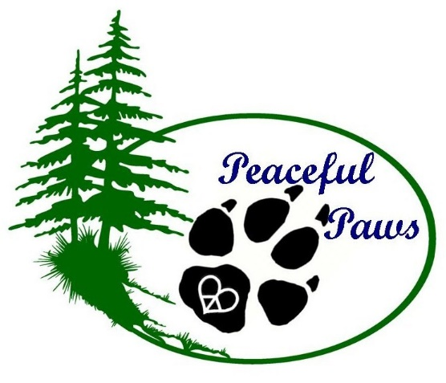
Dog Boarding and Daycare, LLC
Legal Waiver

I understand that I am solely responsible for any harm caused to or by my dog(s) while my dog(s) is/are in the care of Peaceful Paws Dog Boarding and Daycare, LLC. (PPDBDC) I also understand and agree that in admitting my dog(s) PPDBDC has relied upon my representation that my dog(s) is/are in good health and have not harmed, shown aggression or threatening behavior towards any person or animal at any time.
I further understand that due to the way dogs interact and play with one another, cuts, nips, scratches can occur even though the dogs are supervised. Also, that even though all the dogs that attend PPDBDC are fully vaccinated, no vaccine is 100% effective so illness can also occur.
While my dog(s) is/are in the care of PPDBDC, if I am unreachable in the event of an emergency, I hereby authorize PPDBDC, its agents, employees and/or representatives to seek immediate veterinary care for my dog(s). I understand that all costs in connection with veterinary, medical or other treatment, shall be my sole responsibility.
I hereby release and agree to hold harmless PPDBDC , its owners, directors, officers, members, employees and agents from any and all liability, claims, suits, actions, loss, injury or damage of any nature or kind, or for any liability, claims, suits, actions, loss, injury or damage which I or my dog(s) may sustain or which may be caused in any way by my dog(s). I specifically, without limitation, agree to fully indemnify PPDBDC for any and all such liability, claims, suits, actions, losses, injury or damage. I specifically agree to indemnify and hold harmless PPDBDC, as to any loss, cost, claim, injury, damage or liability, sustained or incurred which is caused by an act or omission, whether negligent, intentional or otherwise, of an employee, representative, or agent of PPDBDC.
I understand that if my dog(s) display aggressive, harmful or nuisance behaviors, for the safety of other dogs and the employees of PPDBDC, that my dog may be corrected and/or confined to a separate area until he/she can be picked up. PPDBDC, reserves the right to permanently remove any dog at any time and refuse admittance to any dog(s) which do not meet the health and temperament requirements which include, but are not limited to inoculations for distemper, parvovirus, bordetella, leptosporosis and rabies. As well as completion of an annual fecal exam with the veterinary practice producing a “No Parasites Seen” result.
I agree to pay all charges incurred by the services I or my dog(s) receives while in the care of PPDBDC. If I should not return for my dog, PPDBDC will make every attempt to contact me. If prior arrangements are not made for a “late pick-up” and my dog is not picked up by close of business, a late fee will be assessed and/or my dog will be boarded overnight and a boarding charge will be incurred. If after seven days of no contact from the owner, PPDBDC, will consider the dog(s) abandoned and will re-home the dog(s).
I additionally give consent for my dog(s) to be photographed while in the facilities at PPDBDC and agree to give PPDBDC, the right to use my dog(s) image on promotional materials, which may include its website and Facebook fan pages.
I certify that I have made full disclosure and have read, understand and accept the terms, conditions and statements in this agreement. Furthermore, I acknowledge that this agreement shall be effective and binding upon parties.

_________________________________________________
Signature of Owner and Date

